Which category has the highest share of (active) apps in the market?

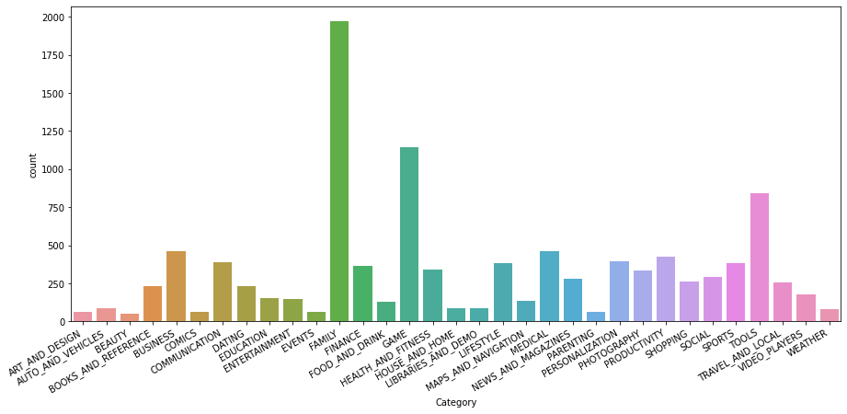

Which Content category has the highest amount of active apps?

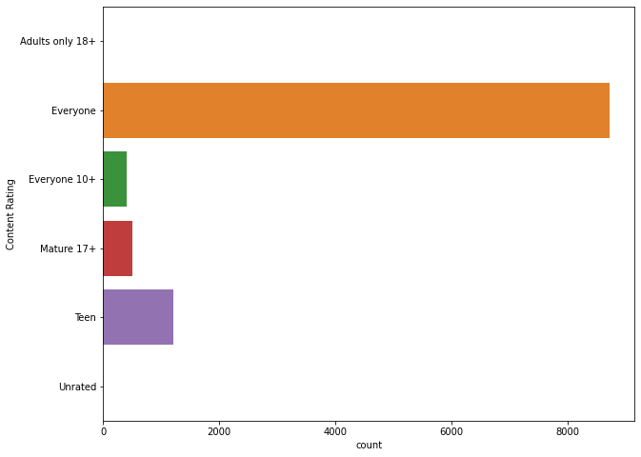

Free Vs Paid App distribution on playstore?

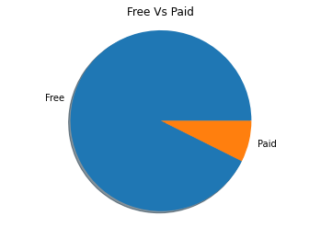

Rating of the apps based on the Content Category which it belongs?

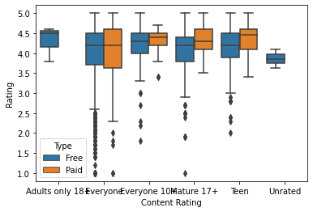

RelationShip between Rating and count of the Reviews?

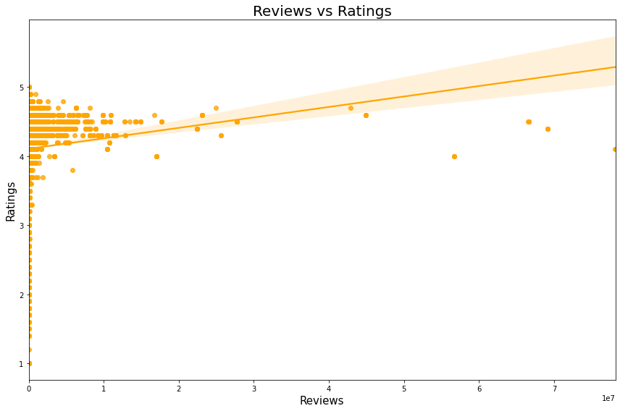

Distribution of the Ratings on the Playstore for all Apps?

